

Job description

AO CMF Europe and Southern Africa Chairperson

AO CMF Europe and Southern Africa is looking for:

highly motivated individual of regional repute and good scientific and clinical recognition. The successful applicant will lead the AO CMF Europe & Southern Africa (ESA) regional affairs by overseeing and managing all educational activities in the region. The applicant needs to be able to work in a multicultural environment with no travel restrictions and is expected to have the vision to lead and contribute to AO CMF ESA region and to help us set new standards, positioning AO CMF as a leader in craniomaxillofacial (CMF) surgery:
Position: AO CMF Europe & Southern Africa (AO CMF ESA) Chairperson
Territory: European Southern Africa Region
Reporting to: AO CMF IB Chairperson
Term: Single term as Chairperson of three years.
One year as "Chairperson Elect" starting on July 1, 2027 and ending June 30, 2028.
One year as "past Chairperson" starting on July 1, 2031 and ending June 30, 2032.
Start date: July 1, 2028
End date: June 30, 2031
Note: The term as "Chairperson Elect" starts as of July 1, 2027, and the term
as "Past Chairperson" continues until June 30, 2032

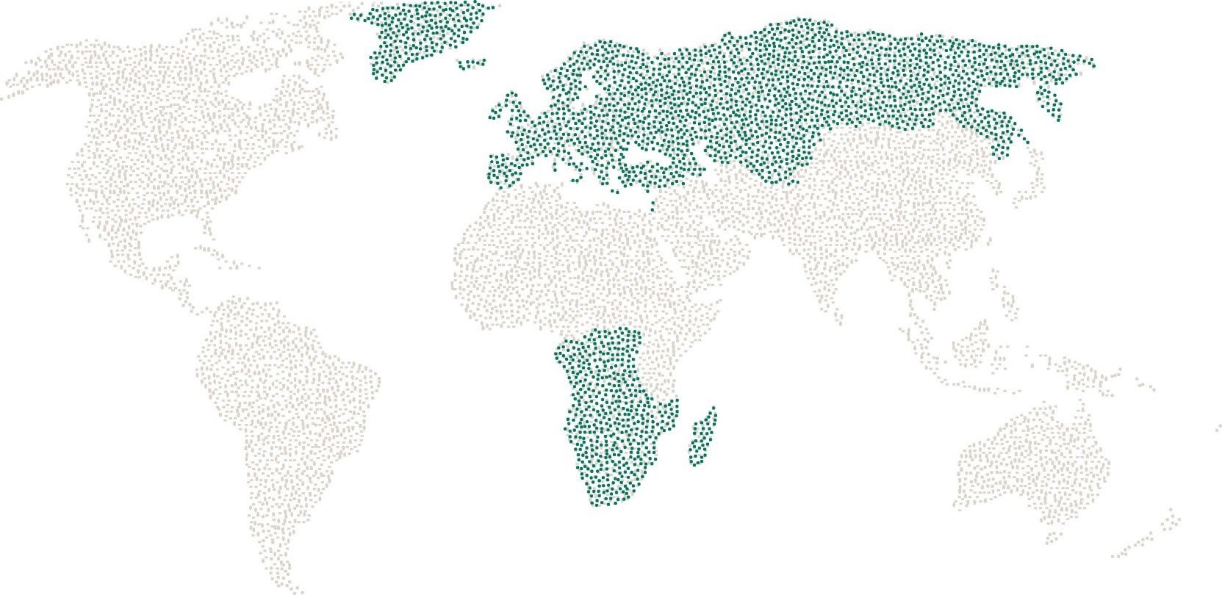

Responsibilities
- Lead the AO CMF ESA regional board
- Support the individual AO CMF ESA Board members in their respective areas
- Position and develop AO CMF as Europe's and Southern African leading community for world class spine surgery education and research
- Lead the development and implementation of long-term strategies, goals and objectives
- Ensure AO CMF understands and meets the needs of spine surgeons across Europe and Southern Africa, through the development of innovative programs and services
- Represent the interests of all members of the community throughout the region
- Build deep and sustainable strategic partnerships and alliances with relevant educational and research organizations
- Be an outstanding ambassador for AO CMF, inspiring European and Southern African spine surgeons to contribute and promoting AO CMF ESA at all opportunities
- Build strong, collaborative relationships with approved industrial partners
- Ensure transparent long-term succession planning
- Represent AO CMF ESA on the AO CMF International Board (IB)
- Oversee the implementation of AO CMF IB and AO Foundation resolutions
- Lead efficient & effective AO CMF ESA regional board meetings
- Ensure consistent quality and brand management in all activities
- Partner with other AO CMF regions and other stakeholders to successfully meet all objectives

Requirements
- Member of AO CMF
- Must be an active CMF faculty residing in the region
- Eligible Candidates:
    - Current or past AO CMF Regional Board members
    - Current or past members of any AO CMF Global Commission (Community Development, Education, Research, TC)
- Must have good regional reputation, strong interpersonal skills, and recognition as a leader
- Be able and willing to work in an ecumenical, constructive, and inclusive way with surgeons of different surgical backgrounds, including but not limited to oral and maxillofacial surgeons, plastic surgeons, otolaryngologists, head and neck surgeons, ophthalmic and oculoplastic surgeons, and neurosurgeons
- Must have regional or international experience (e.g., fellowship, faculty or research travel)
- Recognized member or officer of key national or regional CMF associations are preferred.
- Must be a good communicator and listener with the ability to work in multicultural environments
- Candidates with good project management and delegation skills, as well as willingness and ability to act diplomatically are preferred
- Team builders who can set direction and motivate teams to work together to achieve goals are preferred
- Good command of the English language is desired
- Must be willing and prepared to travel regionally to represent interests of the regional board.
- Must be prepared to spend the equivalent of an average of three days per month on AO CMF affairs
- Must be active AO CMF ESA faculty with at least five years of AO teaching experience after board approval, preferably holding a position at a university or academic institution
- Recognition for outstanding educational achievement is preferred
- Must be highly motivated to build, manage and maintain educational programs
- Must have attended FEP and CEP training

AO CMF International
Clavadelerstrasse 8 | 7270 Davos | Switzerland
Phone: +41 81 414 21 11 | E-mail: info@aospine.org | www.aospine.org

