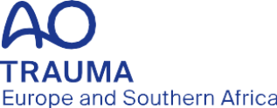

Job description

AO Trauma Europe and Southern Africa Community Development Officer

AO Trama Europe and Southern Africa (ESA) is looking for a highly motivated trauma/orthopedic surgeon who is altruistic, a true team player, and has a vision and clear understanding of how to further develop and strengthen community in Europe and Southern Africa. The successful applicant will lead the AO Trauma ESA activities to develop and coordinate community development projects. The applicant should have broad international experience and be able to work in multicultural environments. The successful applicant must possess strong and refined people skills and a dedication to sharing and encouraging ideas across professional and cultural boundaries.

Position in the Regional Board: AO Trama ESA Community Development Officer
Position in the Regional Committee: AO Trauma ESA Community Development Committee Chairperson
Position in Global Committee: AO Trauma Community Development Commission (AOTCDC) member
Territory: European Southern Africa Region
Reporting to: AO Trauma ESA Chairperson

Term: Single term of four years, no re-election possible
Start date: July 1, 2027
End date: June 30, 2031

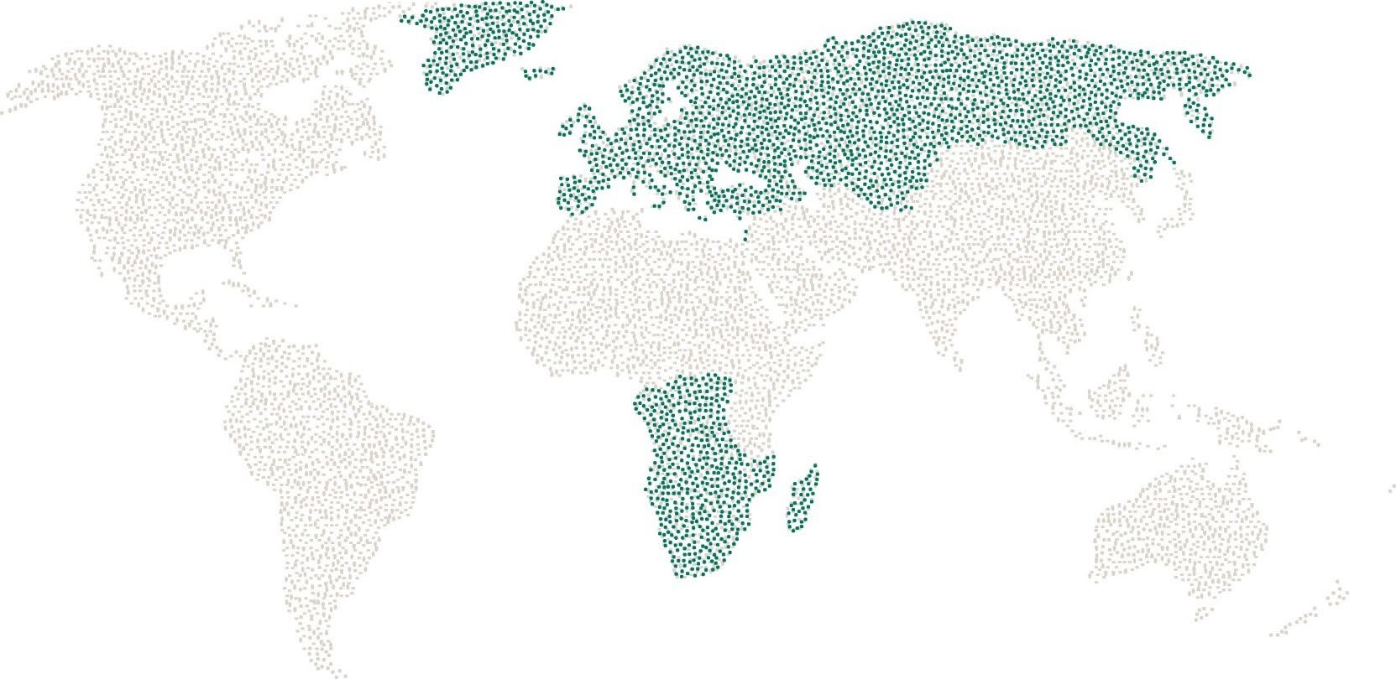

Responsibilities
Is accountable to the Regional AO Trauma Europe and Southern Africa (AO TESA) Board and represents the members of the AO Trauma Europe and Southern Africa community
- Represent the community development on the AO TESA Board
- Review and coordinates Community Development projects in the region
- Ensure that all Community Development activities follow AO Trauma Europe and Southern Africa guidelines and align with AO Foundation values
- Develop a coherent and inclusive AO TESA Community Development strategy in close collaboration with the global AO Trauma Community Development Commission
- Define the AO Trauma Community Development focus and priorities based on identified needs and engagement opportunities within the community
- Develop and coordinate initiatives that strengthen connection, belonging, and collaboration among AO members and faculty
- Promote AO Trauma Membership and Community offerings to increase awareness and perceived value among members and potential members
- Strive for high-quality, impactful community experiences, including society endorsements or partnerships whenever feasible
- Inform regional Community Development Committee Members and national Community Development Chairpersons on their roles and responsibilities related to community engagement and representation
- Ensure fair and transparent involvement of members, faculty, and volunteers in community
- Comply with AO Foundation’s shared values and Code of Ethics.
- Participate and actively contribute to AO TESA Board meetings at least two to three times per year (each meeting: one day plus travelling time)
- Ensure that interests of AO TESA Community Development Committee in the AO TESA Board are well represented
- As a full member of the Europe and Southern African Regional Board participate and actively contribute to discussions and decisions that affect Europe and Southern Africa
- Provide regular community development reports (with the support AO Trauma Europe and Southern Africa Regional Director) to the AO TESA Board

Requirements
- AO Trauma member
- Experience as an AO Trauma officer on a national, regional, or international level
- Active orthopedic trauma surgeon
- Possess a broad personal network and strong relationships with international opinion leaders in trauma and/or orthopedic surgery
- Highly motivated to develop and manage interpersonal connections across professional specialties and to further strengthen AO Trauma Europe and Southern Africa as the leading trauma organization in the region
- Clear communicator and good listener with the ability to work in multi-cultural environments
- Prepared to commit at least 1–2 days per month to AO TESA governance and administration
- Very good command of English
- Ability to communicate with others in a respectful and tactful way that respects cultural, social, academic, and economic differences
- Recognized member of key national, regional, or international orthopedic trauma associations
- Being a current member of the Regional Community & Development Committee is a recommended qualification but is not a mandatory requirement.

Remuneration
- As per AO Foundation‘s guidelines

