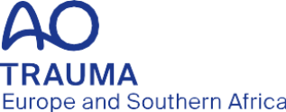

Job description

AO Trauma Europe and Southern Africa Research Officer

AO Trama Europe and Southern Africa (ESA) is looking for a highly motivated individual with a track record in carrying out and managing clinical research at a national or international level. The successful applicant will lead the AO Trauma ESA activities to develop and coordinate research projects. The applicant is expected to have the vision to lead and contribute to AO Trauma Research and to help set new standards and position AO Trauma as an academic leader in orthopedic trauma research. The applicant also needs to be able to work in a multi-cultural environment.
Position in the Regional Board: AO Trama ESA Research Officer
Position in the Regional Committee: AO Trauma ESA Research Committee Chairperson
Position in Global Committee: AO Trauma Research Commission (AOTRC) member
Territory: European Southern Africa Region
Reporting to: AO Trauma ESA Chairperson

Term: Single term of four years, no re-election possible
Start date: July 1, 2027
End date: June 30, 2031

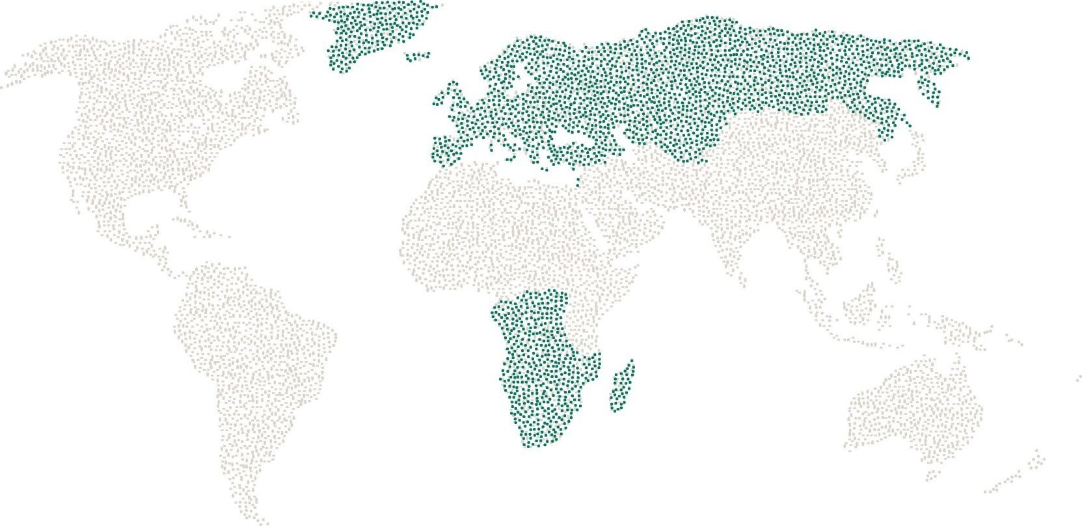

Responsibilities
Is accountable to the Regional AO Trauma Europe and Southern Africa (AO TESA) Board and represents the members of the AO Trauma Europe and Southern Africa community
- Represent research on the AO TESA Board
- Develop a coherent and inclusive AO TESA research strategy in close collaboration with the global AO Trauma Research Commission
- Promotion and further development of the AO TESA Stephan Perren Research Fellowship initiative
- Introduce innovative programs and activities to attract clinicians and researchers to AO TESA
- Collaborate with AO TESA Community Development Committee to support programs
- Collaborate with AO TESA Education Committee to ensure evidence-based information is fed into education programs
- Cultivate mutually beneficial partnerships with academic societies and research bodies
- Ensure the AO Trauma brand is correctly presented on all research materials and at relevant events
- Ensure collaboration with other AO Clinical Divisions, local AO bodies, and approved industrial partners
- Accountable to the AO Trauma Research Commission
- Represent the interests of AO TESA on the global AO Trauma Research Commission
- Support projects initiated by the global AO Trauma Research Commission
- Participate and actively contribute to AO TESA Board meetings at least two to three times per year (each meeting: one day plus travelling time)
- Ensure that interests of AO TESA research in the AO TESA Board are well represented
- As a full member of the Europe and Southern African Regional Board participate and actively contribute to discussions and decisions that affect Europe and Southern Africa
- Provide regular research reports (with the support AO Trauma Europe and Southern Africa Regional Director) to the AO TESA Board

Requirements
- AO Trauma member
- Experience as an AO Trauma officer on a national, regional, or international level
- Active orthopedic trauma surgeon or regionally recognized researcher
- Strong reputation and well published (>15 publications) in high impact journals
- First rate research network and connections including fund raising capabilities
- Experience in multi-center clinical or basic research studies
- Highly motivated to build and manage research programs for all member groups
- Possess a broad personal network and strong relationships with international opinion leaders in trauma and/or orthopedic surgery
- Clear communicator and good listener with the ability to work in multi-cultural environments
- Prepared to commit at least 1–2 days per month to AO TESA governance and administration
- Very good command of English
- Ability to communicate with others in a respectful and tactful way that respects cultural, social, academic, and economic differences
- Recognized member of key national, regional, or international orthopedic trauma associations
- Being a current member of the Regional Research Committee is a recommended qualification but is not a mandatory requirement.

Remuneration
- As per AO Foundation‘s guidelines

